POCKETWISE
Finance Tracker System Requirements Specification (SRS)

1. Introduction

1.1. Scope
This system is a mobile application that enables users to:
- Track income and expenses with fast, low-effort entry
- Fast manual transaction entry assisted by predictive defaults
- Create and manage personalized category budgets with real-time progress
- Set and monitor savings goals with progress tracking
- View spending analytics and category breakdowns
- Use the app fully offline, with automatic sync once connectivity returns
- Benefit from rule-based smart entry (default suggestions, recurring-transaction detection)
The system is designed for individual users, with particular attention to the mobile-money first, sometimes offline context common in Cameroon. Receipt OCR, voice/natural-language input, AI/ML-based insights, and Mobile Money SMS auto-capture are nice to haves for this system.

1.2. Objective
The main objective is to develop a cross-platform mobile personal finance management system that simplifies and accelerates transaction recording while providing intelligent financial insights, marketable to the Cameroonian and broader African market.
- Record income and expenses quickly.
- Reduce manual data entry.
- Automate transaction categorization.
- Help users monitor budgets.
- Track savings goals.
- Generate spending analytics.
- Provide personalized recommendations.

2. Overall Description

2.1. Product Perspective
This is a mobile application accessible on Android and iOS devices. Users interact with the system through a Flutter interface backed by local, offline-first storage.
- Frontend: Flutter (Dart) cross-platform mobile client
- Local storage: SQLite on-device (offline-first source of truth for the UI)
- Backend: RESTful API built with FastAPI (Python)
- Database: PostgreSQL for server-side persistence
- Authentication: JWT-based, issued and verified by the backend
- Sync: background service reconciling local and server data by last-modified timestamp

2.2. Product Features
- User registration and authentication (email/phone and password, JWT session)
- Quick transaction entry (amount, category, description, payment method, date)
- One-tap quick-amount shortcuts based on personal frequency
- Predictive category suggestion from description text as the user types
- Recurring transaction detection and one-tap re-logging
- Custom and default category management (create, edit, archive)
- Payment method management (cash, MoMo, Orange Money, bank, card)
- Offline-first local storage with automatic background sync
- Conflict resolution for records edited on multiple devices
- Budget creation per category with weekly/monthly periods
- Real-time budget progress tracking with near-limit warnings
- Savings goals with target amount, target date, and progress tracking
- Spending analytics dashboard (category breakdown, trends over time)
- Rule-based personalized recommendations (e.g. category overspend alerts)
- Data export (CSV, PNG, PDF) for personal records
- Voice-to-transaction entry (nice to have)
- MoMo / Orange Money SMS auto-capture (nice to have)
- 50/30/20 rule budgeting as an alternative to per-category budgets
- Debts & money owed tracking, in both directions
- Privacy Mode to mask sensitive amounts with a single tap

2.3. User Characteristics
Target Users:
- Individuals managing personal income and expenses
- Students, young professionals, and small business owners with irregular income
- Users transacting primarily in cash and mobile money, with intermittent internet access
- Basic smartphone literacy assumed, no specialized financial or technical knowledge required

2.4. Assumptions and Dependencies
- Users have a smartphone with intermittent (not necessarily constant) internet access
- Users provide reasonably accurate financial information
- A single currency (XAF) is sufficient for this iteration
- A free tier is sufficient for the deployment
- Users have a valid email address for registration

3. User Stories & Use Cases

3.1. User Personas

Persona 1: Glenys, the University Student
20, studies in Yaoundé, receives an irregular monthly allowance from her family via MoMo plus occasional tutoring income. Spends mostly cash at the market and MoMo for airtime and transport. Wants to stop running out of money before month-end without maintaining a complicated budget.

Persona 2: Junior, the Market Trader
34, sells electronics accessories in a Yaoundé market. Handles many small cash and MoMo transactions daily and has no time to type descriptions mid-sale. Also regularly lends small amounts to regular customers and needs to remember who owes him.

Persona 3: Delphine, the Young Professional
28, works in Douala, paid by bank transfer but spends primarily via MoMo and cash. Wants to save toward specific goals and check her balance discreetly when her phone is visible to others, such as on public transport.

3.2. User Stories

Transaction Logging
- As a market trader, I want to log a cash sale in under 5 seconds, so that logging never interrupts serving a customer.
- As a student, I want the app to suggest a category as I type a description, so that I don't have to scroll through a category list every time.
- As any user, I want to tap a recent amount instead of typing it, so repeat purchases log almost instantly.

Budgeting
- As a student who finds category-by-category budgeting tedious, I want a simple 50/30/20 split of my income, so that I get budgeting guidance without setting up individual limits.
- As a young professional who prefers granular control, I want to set a specific budget per category, so that I can track categories that matter most to me.
- As any user, I want a visible warning when I'm approaching a budget limit, so I can adjust before overspending.

Debts & Money Owed
- As a market trader, I want to record who owes me money and how much, so I don't have to rely on memory.
- As any user, I want to record money I owe someone else, so my full financial picture — not just my own spending — is visible in one place.
- As any user, I want to mark a debt as settled without losing the record, so I keep a history of who has paid me back.

Privacy
- As a young professional checking her balance on public transport, I want to hide all amounts with one tap, so people around me can't see my finances.
- As any user, I want Privacy Mode to stay on until I turn it off, so I don't have to re-enable it every time I open the app.

Offline Use & Trust
- As a market trader in an area with unreliable network, I want to log transactions without an internet connection, so poor connectivity never blocks my record-keeping.
- As any user, I want the app to work without a bank account, so I'm not excluded by not having formal banking.

3.3. Use Cases

UC-1: Log a Quick Transaction
Actor: Registered user. Preconditions: user is logged in; app is open, with or without connectivity.
1. User taps the Quick Add button.
2. User enters or taps a suggested amount.
3. System suggests a category based on description text, if any.
4. User confirms or overrides the category and selects a payment method.
5. User taps Save; the system writes the transaction to local storage instantly.
Postcondition: transaction is saved locally and reflected immediately on the dashboard and any relevant budget.

UC-2: Set Up a 50/30/20 Budget
Actor: Registered user. Precondition: user is logged in and has not yet configured a budgeting mode.
1. User navigates to Budgets and selects “50/30/20 rule.”
2. User confirms or edits their monthly income.
3. System calculates Needs/Wants/Savings targets and maps existing categories into each group.
4. User adjusts any category's group assignment if desired.
5. System begins tracking spend against each of the three groups.
Postcondition: the Budgets screen shows three group-level progress bars instead of per-category ones.

UC-3: Record a Debt
Actor: Registered user. Precondition: user is logged in.
1. User navigates to Debts and taps “+ New.”
2. User enters the person's name, amount, and direction (owed to me / owed by me).
3. User optionally sets a due date and note.
4. User saves the debt.
Postcondition: the debt appears in the relevant running total (owed to user or owed by user) and, if a due date was set, a reminder is scheduled.

UC-4: Toggle Privacy Mode
Actor: Registered user. Precondition: user is logged in and viewing any screen showing monetary amounts.
1. User taps the Privacy Mode control on the Dashboard.
2. System immediately masks all monetary amounts across every open and subsequently opened screen.
3. State persists across app restarts until the user taps the control again.
Postcondition: no amount is rendered in plain text anywhere in the app, including OS-level previews, until Privacy Mode is turned off.

UC-5: Sync Offline Transactions
Actor: System (Sync Manager), triggered automatically. Precondition: one or more records exist locally with synced = false.
1. Sync Manager detects an active internet connection.
2. Sync Manager batches all unsynced local records into a single request.
3. Backend validates and persists records, resolving any conflicts by last-modified timestamp.
4. Sync Manager marks local records as synced.
Postcondition: local and remote data are consistent with no user action required.

4. Functional Requirements

4.1. User Authentication
Users can register, log in, and manage a simple authenticated session.
- The system shall allow new users to register with an email and password [Must]
- The system shall enforce a minimum password length of 8 characters [Must]
- The system shall authenticate users using JWT tokens [Must]
- The system shall persist the session locally so the user remains logged in across app restarts [Must]
- The system shall allow the user to log out, clearing the local session [Must]
- The system shall hash passwords using bcrypt before storage [Must]
- The system shall validate email format during registration [Must]
- The system shall prevent duplicate email registrations [Must]
- The system shall require at least one successful online login before offline use is possible [Must]
- The system shall provide password reset via email [Could]

4.2. Dashboard
Central overview screen displaying key financial metrics and recent activity.
- The system shall display current balance (income − expenses) [Must]
- The system shall display total income and total expenses for a selected period [Must]
- The system shall show the most recent transactions [Must]
- The system shall show a budget status snapshot across categories [Must]
- The system shall show a savings goals snapshot [Should]
- The system shall provide period selection filters (this month, this year, all time) [Should]
- The system shall show a helpful empty state for a new user with no data yet [Must]
- The system shall refresh dashboard data automatically after a relevant user action [Must]
- The system shall provide a single-tap entry point to add a new transaction [Must]

4.3. Transaction Management
Complete transaction lifecycle: creation, viewing, editing, and deletion.
- The system shall provide a form to add a new transaction with amount, category, type, and date [Must]
- The system shall allow an optional description and payment method on a transaction [Must]
- The system shall validate all inputs before saving [Must]
- The system shall write a new transaction to local storage instantly, before any network call [Must]
- The system shall allow editing of an existing transaction [Must]
- The system shall allow deletion of a transaction with a confirmation prompt [Must]
- The system shall display a transaction list with visual income/expense indicators [Must]
- The system shall present the user's most frequent amounts as tappable quick-entry shortcuts [Should]
- The system shall pre-fill a likely category/payment method based on the user's past entries [Should]
- The system shall support search and filtering of transactions by date range, category, or amount [Should]
- The system shall support sorting by date or amount, ascending or descending [Should]
- The system shall calculate and display totals for a filtered transaction list [Should]
- The system shall detect repeated amount/category/payment-method combinations and offer one-tap re-logging [Should]
- The system shall allow a user to manage payment methods, including cash, MoMo, Orange Money, and bank [Must]

4.4. Budget Planner
Budget creation and monitoring with visual progress and threshold alerts.
- The system shall allow the user to set a weekly or monthly budget limit per category [Must]
- The system shall display budget versus actual spend for each category [Must]
- The system shall calculate remaining budget for each category [Must]
- The system shall show a visual progress bar for budget utilization [Must]
- The system shall allow editing and deletion of a budget entry [Must]
- The system shall show month-to-date or week-to-date spend against the active budget [Must]
- The system shall notify the user when spend crosses 80% and 100% of a category budget [Should]
- The system shall visually highlight a category that has exceeded its budget [Should]
In addition to per-category budgets, the system shall offer the 50/30/20 rule as an alternative, lower-effort budgeting mode — allocating income into Needs (50%), Wants (30%), and Savings (20%) without requiring the user to define individual category limits.
- The system shall allow the user to choose between custom per-category budgeting and the 50/30/20 rule when creating a budget plan [Must]
- The system shall calculate Needs/Wants/Savings targets automatically from the user's declared or detected income [Must]
- The system shall map each category to one of Needs, Wants, or Savings by default, with the user able to reassign a category's group [Should]
- The system shall display progress against each of the three 50/30/20 groups using the same visual progress treatment as category budgets [Should]
- The system shall allow the user to switch between budgeting modes without losing transaction history [Should]

4.5. Category Management
Default and user-created categories for classifying transactions.
- The system shall provide a set of default categories for income and expense [Must]
- The system shall allow the user to create and edit custom categories [Must]
- The system shall classify each category by type (income or expense) [Must]
- The system shall prevent duplicate category names for the same user [Must]
- The system shall prevent archive or deletion of a category that has existing transactions [Must]
- The system shall show a category picker during transaction entry [Must]

4.6. Savings Goals
Goal setting and progress tracking.
- The system shall allow the user to create a savings goal with a name and target amount [Must]
- The system shall allow an optional target date on a goal [Must]
- The system shall display visual progress toward each goal [Must]
- The system shall calculate percentage completion automatically [Must]
- The system shall allow multiple active goals at once [Must]
- The system shall allow editing and deletion of a goal [Must]
- The system shall show time remaining until a goal's target date [Should]

4.7. Debts & Money Owed
Tracks informal money owed in either direction that is; money the user has lent to someone, and money the user has borrowed.
- The system shall allow the user to record a debt with a person's name, amount, direction (owed to the user, or owed by the user), and optional due date [Must]
- The system shall display separate running totals for total money owed to the user and total money the user owes [Must]
- The system shall allow the user to mark a debt as settled without deleting its historical record [Must]
- The system shall allow optional notes on a debt record (e.g. reason, reminder context) [Should]
- The system shall send a local notification when a debt's due date is approaching [Should]
- The system shall allow a settled debt to optionally generate a corresponding income or expense transaction [Could]

4.8. Reports & Analytics
Visual reporting on spending patterns.
- The system shall display a category-wise spending breakdown chart over a selectable amount of time [Must]
- The system shall display a spending trend view over time (weekly/monthly) [Must]
- The system shall display an income-versus-expense comparison [Should]
- The system shall show the user's top spending categories for a period [Should]
- The system shall generate a rule-based recommendation when a category's spending deviates significantly from the user's own historical average [Could]
- The system shall allow a custom date range selection for a report [Could]
- The system shall export transaction data to CSV, PNG, PDF [Could]

4.9. Offline Support & Synchronization
This is the architectural core of the system: every feature above must remain usable without a network connection.
- The system shall make all core actions (add/edit/delete transaction, view budgets, view analytics) fully usable with no network connection [Must]
- The system shall treat local SQLite as the source of truth for the UI at all times [Must]
- The system shall queue any unsynced change locally with a synced flag and device identifier [Must]
- The system shall push queued changes to the backend automatically once connectivity is detected [Must]
- The system shall pull remote changes and merge them into local storage [Must]
- The system shall resolve conflicting records by comparing last-modified timestamps [Must]
- The system shall allow the user to trigger a manual sync [Should]
- The system shall show a visual indicator of sync status (synced / pending) [Should]

4.10. Smart Entry & Recurring Detection
Rule-based logic that reduces repetitive input without external AI services. No third-party AI/ML API is used in this.
- The system shall suggest a category and payment method based on the user's own transaction history [Should]
- The system shall detect a repeating transaction (same amount and category within a recurring interval) and prompt the user to log it again in one tap [Should]
- The system shall surface simple rule-based tips (e.g. proximity to a budget limit) on the dashboard [Could]

4.11. Settings & Profile Management
Basic user preferences and account management.
- The system shall allow the user to update their profile name [Could]
- The system shall allow currency preference selection (single currency, default XAF) [Could]
- The system shall allow the user to change their password [Could]
- The system shall persist user preferences locally between sessions [Must]

4.12. Privacy Mode
A one-tap way to hide sensitive amounts on screen. Useful when checking the app in public, on transport, or in front of a customer.
- The system shall provide a single-tap control, accessible from the Dashboard, to toggle Privacy Mode on or off [Must]
- When Privacy Mode is active, the system shall mask all monetary amounts across every screen (Dashboard, Transactions, Budgets, Goals, Debts, Analytics) using a placeholder in place of the figure [Must]
- The system shall preserve Privacy Mode's on/off state across app restarts [Should]
- The system shall exclude masked amounts from the operating system's app-switcher preview and notification previews [Should]
- The system shall allow the user to reveal an individual masked amount with a tap-and-hold, without disabling Privacy Mode entirely [Could]

4.13. Notifications
Local, on-device notifications only, no server-side push infrastructure is built this iteration.
- The system shall send a local notification when a budget threshold is crossed [Should]
- The system shall send a local notification prompting the user to confirm a detected recurring transaction [Should]

4.14. Error Handling and Session Management
- The system shall handle network errors gracefully by queuing the action for later sync rather than failing [Must]
- The system shall display clear, user-friendly error messages [Must]
- The system shall validate all API responses before updating local state [Must]
- The system shall redirect the user to the login screen when a session token is invalid or expired [Must]
- The system shall log errors locally to support debugging during development [Should]

5. Non-Functional Requirements

5.1. Performance
- Logging a typical transaction shall complete in under 5 seconds end-to-end on-device, including the local save
- Backend API read requests shall respond in under 300ms under normal load
- The system shall support at least 1,000 transactions per user without perceptible slowdown
- Background sync shall not block or noticeably delay any user-facing interaction.
- Local and remote database queries shall use appropriate indexes

5.2. Security
- Passwords shall be hashed before storage
- All user inputs shall be validated on both client and server
- JWT tokens shall have a defined expiry with a refresh mechanism
- All client-server communication shall use HTTPS
- The authentication token shall be stored using secure on-device storage, not plain SQLite
- Sensitive data shall not be exposed in API responses beyond what the client needs
- Locally stored financial data shall be protected by the device's app sandbox. Sensitive fields should be encrypted at rest where the platform allows
- Privacy Mode's masking shall be enforced at the UI rendering layer, so masked amounts are never briefly visible during screen transitions

5.3. Usability
- A first-time user shall be able to add a transaction without instructions, in three taps or fewer beyond opening the add-transaction screen
- Navigation shall be consistent across all screens
- Error messages shall be clear and actionable
- Loading indicators shall be shown for network operations only but local operations must feel instant
- Empty states shall guide the user toward a next action
- The app shall minimize data usage during sync, batching requests rather than syncing record-by-record

5.4. Reliability
- No data shall be lost on app crash or forced close. Local writes are committed before the UI confirms success
- Failed sync attempts shall retry automatically with a backoff strategy
- The system shall recover gracefully from a failed API call without corrupting local state
- Data shall be validated at both the local and remote layers

5.5. Compatibility
- The application shall run on Android 8.0+ and iOS 13+
- The layout shall adapt to common phone screen sizes
- The application shall remain usable on lower-end devices with limited RAM and storage

5.6. Maintainability
- Code shall follow a modular architecture separating local storage, remote API access, and UI layers
- Client and server data models shall be explicitly typed
- The project shall use Git for version control with regular, descriptive commits
- Code shall be linted and formatted consistently (flutter analyze; ruff/black for Python)
- The mobile client shall run on both Android and iOS from a single Flutter codebase

5.7. Scalability
- The backend architecture shall support horizontal scaling of the API layer independently of the database as user numbers grow

6. System Architecture

6.1. Architectural Design
The system follows an offline-first, layered architecture shown below: the Flutter client always reads and writes to local SQLite first for instant response, a Sync Manager reconciles changes with the FastAPI backend once connectivity is available, and the backend persists data to PostgreSQL.
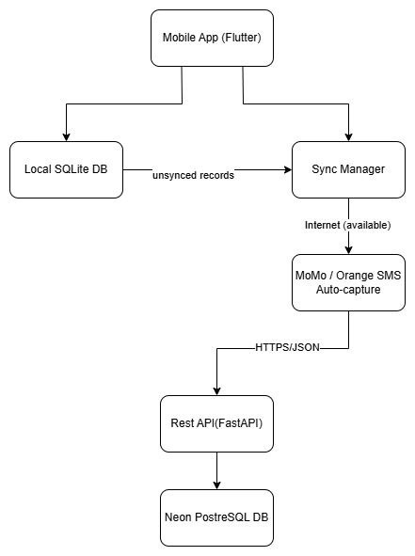
Figure 6.1 — High-level system architecture

6.2. System Flow
- App launches and checks for a cached session
- If a valid session exists, the dashboard loads immediately from local data, no network required
- User performs an action (e.g. add transaction); it is written to local SQLite instantly and the UI updates immediately
- The change is queued with a synced=false flag
- When connectivity is detected, the background sync service pushes queued changes to the backend
- The backend validates and persists the changes to PostgreSQL
- The service then pulls any remote changes and merges them locally, resolving conflicts by updated_at timestamp

6.3. Database Design (ERD)
The schema is normalized around a single User entity. Transaction is the central fact table, referencing Category and Payment Method. Budget, Savings Goal, Recurring Pattern, and the new Debt entity are independent tables that also reference User, keeping the model easy to extend.
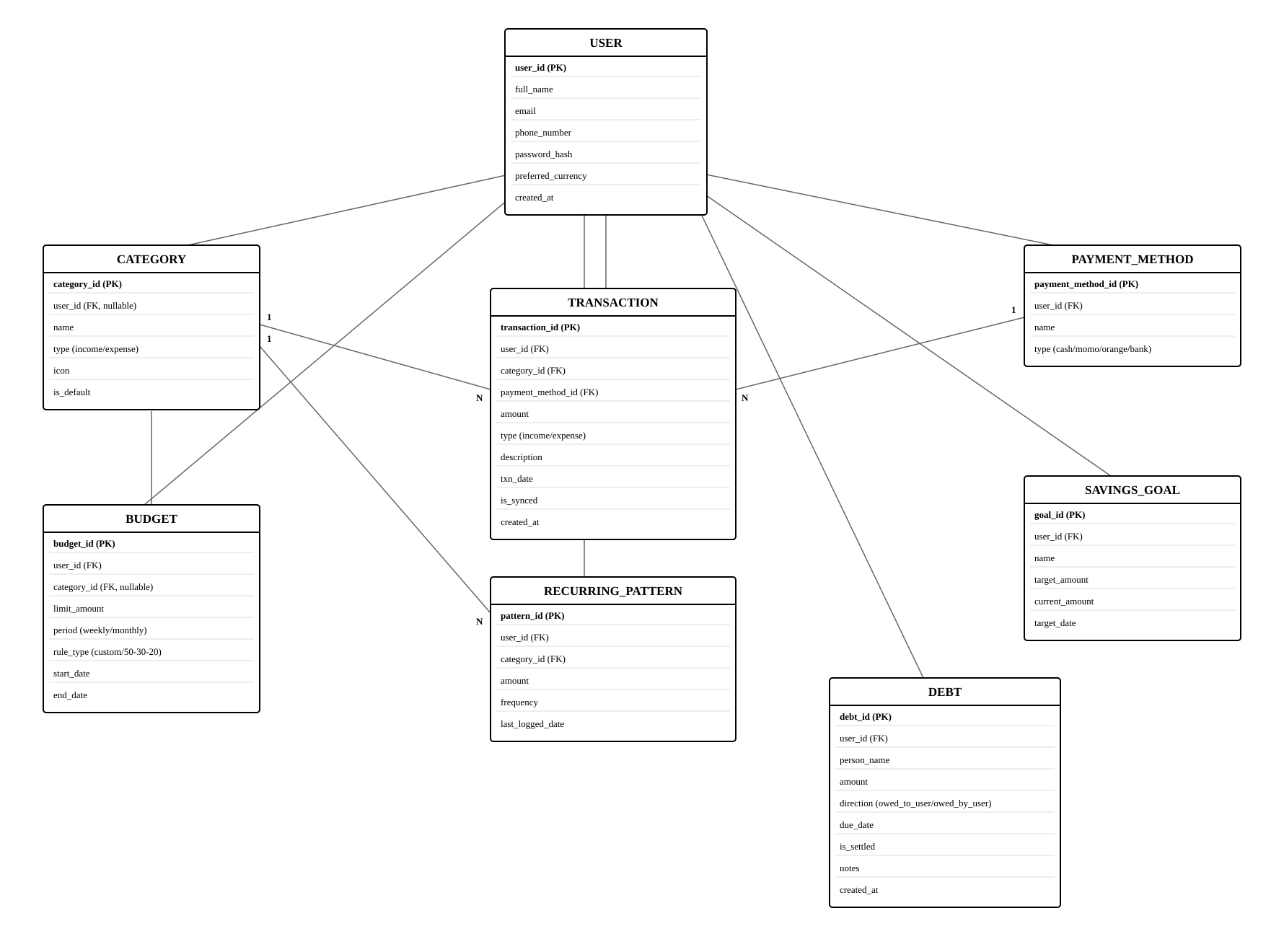
Figure 6.2 — Entity-Relationship Diagram for Pocketwise

Entity notes
- User — a registered account; parent of every other entity.
- Category — classifies transactions as income or expense; category_id is nullable on Budget to support the 50/30/20 rule, which allocates by group rather than by individual category.
- Payment Method — how a transaction was paid (cash, MoMo, Orange Money, bank, card).
- Transaction — a single income or expense record.
- Budget — a spending limit either per category (custom) or per 50/30/20 group (rule_type field distinguishes the two modes).
- Savings Goal — a target amount and date the user is saving toward.
- Recurring Pattern — a detected repeated transaction used to power one-tap re-logging.
- Debt — an amount owed, in either direction: money the user is owed by someone else, or money the user owes someone else. The direction field distinguishes the two.

7. API Design
The backend exposes a versioned REST API (/api/v1/) returning JSON. All endpoints except registration and login require a Bearer JWT in the Authorization header.

7.1. Authentication
- POST /api/v1/auth/register — create a new user account
- POST /api/v1/auth/login — authenticate and receive a JWT access/refresh token pair
- POST /api/v1/auth/refresh — exchange a refresh token for a new access token

7.2. Transactions, Categories & Payment Methods
- GET /api/v1/transactions — list transactions, filterable by date range, category, or amount
- POST /api/v1/transactions — create a new transaction
- PUT /api/v1/transactions/{id} — update an existing transaction
- DELETE /api/v1/transactions/{id} — delete a transaction
- GET /api/v1/categories — list default and user-created categories
- POST /api/v1/categories — create a custom category
- GET /api/v1/payment-methods — list the user's payment methods

7.3. Budgets & Savings Goals
- GET /api/v1/budgets — list active budgets with current progress
- POST /api/v1/budgets — create a budget; body includes rule_type (custom or 50-30-20) and, for custom budgets, a category_id and limit_amount
- GET /api/v1/budgets/50-30-20-summary — return the user's income-derived Needs/Wants/Savings targets and current allocation against each group
- GET /api/v1/goals — list savings goals with progress
- POST /api/v1/goals — create a savings goal

7.4. Debts & Money Owed
- GET /api/v1/debts — list debts, filterable by direction (owed_to_user / owed_by_user) and settlement status
- POST /api/v1/debts — create a debt record
- PUT /api/v1/debts/{id}/settle — mark a debt as settled without deleting its history

7.5. Analytics, Privacy & Sync
- GET /api/v1/analytics/summary — category breakdown and income/expense totals for a period
- GET /api/v1/analytics/recommendations — rule-based insights from recent spending patterns
- PUT /api/v1/users/me/privacy-mode — toggle Privacy Mode server-side so the preference follows the user across devices
- POST /api/v1/sync/batch — accept a batch of locally created/modified records and return conflict-resolved results

8. User Interface Requirements

8.1. Navigation
- Bottom navigation bar with Dashboard, Transactions, Budgets, Analytics, and Settings
- Active tab clearly indicated
- Consistent back-navigation behavior across all screens
- Splash screen as the entry point, routing to Login or Dashboard based on session state
- Debts & money owed is reachable from the Dashboard and from a dedicated screen under Settings, rather than occupying a sixth bottom-navigation slot

8.2. Forms
- Clear labels for all input fields
- Inline validation with real-time feedback
- Numeric keypad shown for amount fields
- Category picker and date picker used where relevant
- Loading state shown only for operations that require the network
- Clear success/error feedback after form submission

8.3. Visual Design
- Clean, card-based layout with consistent spacing
- Consistent color scheme carried through from project branding
- Charts used for analytics and budget/goal progress
- Empty states with helpful guidance for new users
- Amounts shall be visually masked (e.g. ••••) rather than removed from layout when Privacy Mode is active, so screen structure stays consistent

8.4. Accessibility
- Sufficient color contrast between text and background
- Scalable text respecting system font-size settings
- Adequately sized touch targets for mobile interaction
- Descriptive labels on interactive elements for screen-reader compatibility

9. Implementation Constraints

9.1. Technical Constraints
- Must use Flutter for the cross-platform mobile client
- Must use FastAPI and PostgreSQL for the backend
- Must implement offline-first local storage as the primary data path
- Must use JWT for authentication
- Must deploy the backend to a host reachable during development and demonstration
- Must use Git for version control
- Must use environment variables for configuration and secrets

9.2. Business Rules
- Each user can access only their own data
- Transaction amounts must be positive numbers
- Budget amounts must be positive numbers
- A category cannot be deleted if it has existing transactions
- A savings goal's target amount must be greater than zero
- Email addresses must be unique across the system
- A debt (money owed) amount must be a positive number
- Marking a debt as settled shall not delete its historical record

9.3. Development Constraints
- Must Have features take strict priority over Should Have and Could Have features
- Testing shall be performed continuously during development
- Documentation (this SRS and the project report) shall be maintained alongside development

10. Appendices

10.1. Future Enhancement
- Receipt scanning and OCR that is upload or photograph a receipt to auto-fill a transaction
- Voice input and natural-language transaction entry
- AI/ML-based categorization, spending predictions, and personalized insights
- Mobile Money (MTN MoMo, Orange Money) SMS auto-capture of transactions
- Multi-currency support with exchange-rate handling
- Family or shared budgets and multi-user accounts
- Achievements, streaks, and other gamification
- Home-screen widgets
- Password reset via email
- PDF report export

